

**Software Engineering and Testing. BSC Year 2, 2024/2025**

**Assessment 4: Software Testing**

**Submitted by:**

**B00160049 Matthew Keenan**

**B00159340 Stanislav Kolev**

**B0016388 Fabio Melilo**

**Submission date**

**24/3/25**

**Declaration**

I herby certify that this material, which I now submit for assessment on the programme of study leading to the award of Ordinary Degree in Computing in the Institute of Technology Blanchardstown, is entirely my own work except where otherwise stated.

Author: B00160049 Matthew Keenan Dated: 24/3/25

Author: **B00159340 Stanislav Kolev** Dated: 24/3/25

Author: **B0016388 Fabio Melilo** Dated: 24/3/25

**Table of Contents**

Project Definition Pg 4-5

Document Revision Pg 5

Methodology Pg 5-6

Requirements Pg. 7-9

Case Diagrams Pg. 10-14

Conclusion Pg 15-16

Unit Testing

**User (getter/setters)**

In user class test we take the getUsername and setUsername methods by creating an array of usernames and then in a for each loop creating a new user and setting their username as the same spot in the array

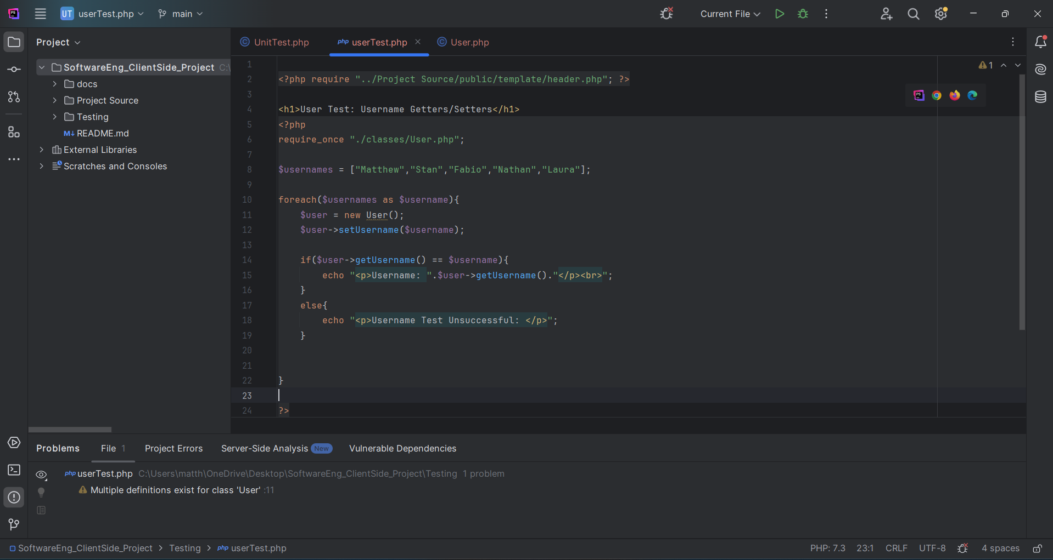

And we show it working in the browser like this:

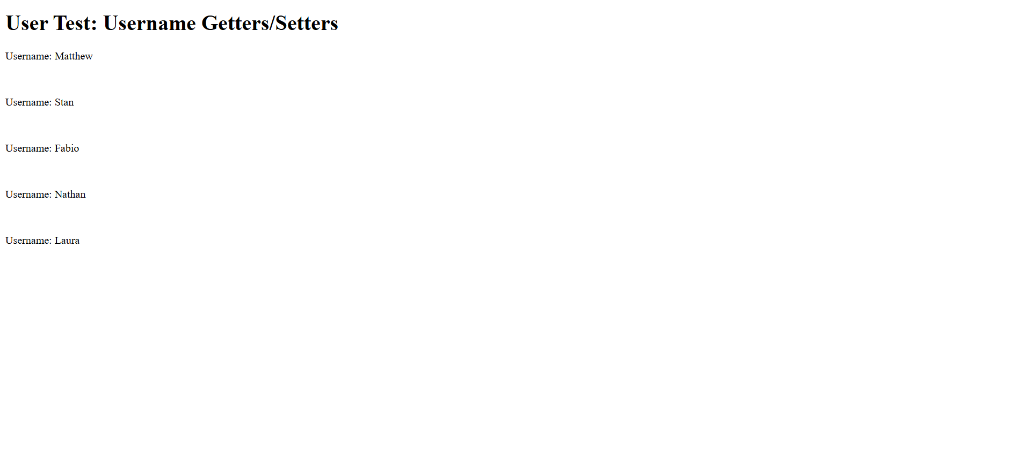

**Movie**

For the movie test the method fetchAllMovies and this is done by connecting to the database checks if the data is received and then they are displayed

**Booking**

This a similar test to the user test but instead of testing the username we’re testing the card number

UI Testing

**Consistency**

The same design across all pages.

Consistency is shown on the website has the same colour and style throughout the website and the navbar styling is consistent throughout.

Index Page

Products Page

Booking Page

**Minimal Clicks**

Keeping the clicks required to complete the main function of the website e.g. booking a ticket or writing a review

Booking takes five clicks as you must login, confirm, pick movie, click book, and click purchase.

Were as making a review only takes four clicks as the reviews can be made on the product page

**Recoverability**

Being able to undue mistakes made on the website e.g. going back to a previous page.

On the website recoverability is shown by each page’s ability to go back to the home page for the movie page it’s the back to movies button and cancel for booking.

**Guidance**

The UI design assists users in how to use the website e.g. instructions displayed throughout on buttons like submit, back to home etc

The website uses guidance as the movies are front and centre on the main page and on the product page there are buttons to indicate that you should go back to movies or book a movie and a large banner showing more movie options

On The Booking page it guides the user by having placeholder to show what inputs expected as well as a submit button to tell the user what to do once the forms filled out

Minimal Surprise

The user interface must not surprise the user. Everything should be as shown e.g a booking button under the godfather should bring the user to a booking ticket for the godfather and not another movie

The website uses minimal surprise as every input and button does exactly what is stated for example the back to movies button brings you back to the main page and submit buttons submit the forms users’ input.

